Skipping Rope Adult For Men and Women, Adjustable Jump Rope with Anti-Slip Foam Handle Exercise Rope, Ergonomic Jump Rope Multi Color Option
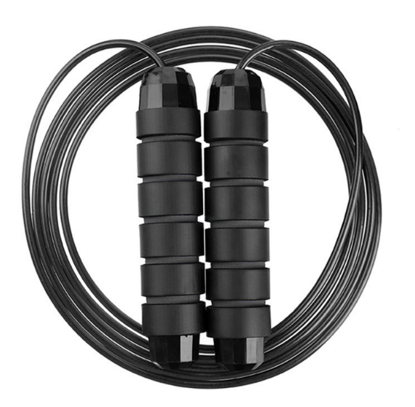

About this item
- ANTI-SLIP MEMORT FOAM HANDLE | Your comfort is our first priority, anti-slip light weight ergonomically shaped handles with soft memory foam grips for extra comfort.
- ADJUSTABLE FOR PERFECT SIZE | Adjust the length of the rope quickly and easily. Its adjustable 3m length design allows you to customize the length to suit your needs, making it suitable for all ages and all skill levels. Your order includes a set of spare adjustment buckles.
- QUALITY AND DURABILITY | can withstand long-term movement even after a long time of movement, even also rough ground it can also be used , ensures that the rope will not be tangled and has a long service life. Not have rope twisted worries any more
- 360° ROTATION & COMFORT | Adjustable speed jump rope, can be quickly adjusted to the required length, making it suitable for everyone, all ages and all skill levels. You could easily swing the skip ropes by 360°rotation.
- MULTIPURPOSE SKIPPING ROPE | Fitness can help us relax very well, suitable for adults and children, it can effectively help you exercise wrists, leg strength and drive other body parts together, speeds up calorie consumption. A great choice for MMA, boxing and cross training.

- Part number: JUMP-ROPE-BLK
- Length:2.8 m (Personal)
- Material:PU Rope
- Gender:unisex
- Single package size: 21X17.5X2 cm
- Single gross weight:1.000 kg

